**Line Follower**

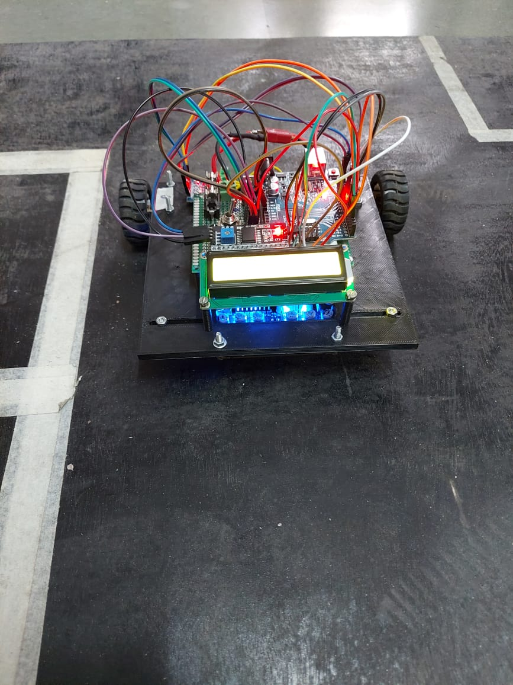

**Team Members:**

Hrishikesh Kshetramade (Electronics)

Palash Rambhia (Coding)

Pranav Joshi (Coding)

**Components Used:**

Arduino Uno

N20 Gear Motors (2)

L9110S motor driver (1)

IR sensors (8)

**Motor Drivers:**

L9110S motor driver

**Description**

The line follower robot is an automated vehicle that follows a white line embedded on the surface. In most of the line followers there are 2 IR sensors used but to improve our accuracy we have included not 2 or 3 but a total of 8 IR sensors, so that we can calibrate and make sharp and accurate turns.